**Exploratory Testing**

**Project Name:** IMDb

**Test Data:** [www.IMDb.com](http://www.IMDb.com)

**Created by:** Leyla

1. **Understand the Product**

IMDb is the world's most popular and authoritative source for movie, TV and celebrity content, designed to help fans explore the world of movies and shows and decide what to watch.

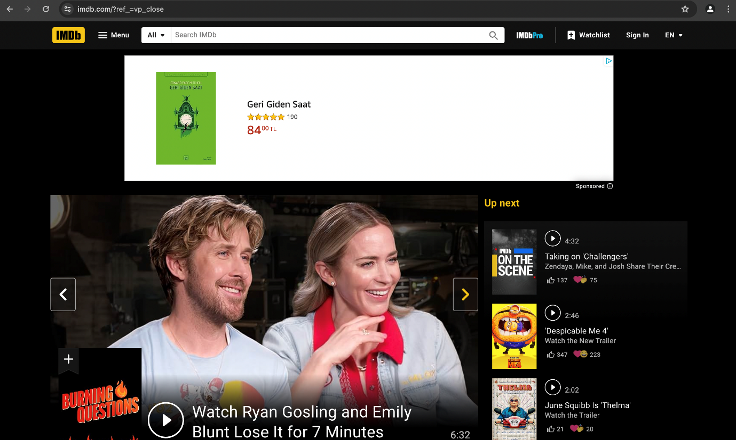

1. **Search Functionality Testing**

By entering keywords on a search bar related to movies, TV shows, actors, or genres I was successfully led to the expected pages. Relevant search results displayed accurately and promptly. There were no issues identified with the search bar.

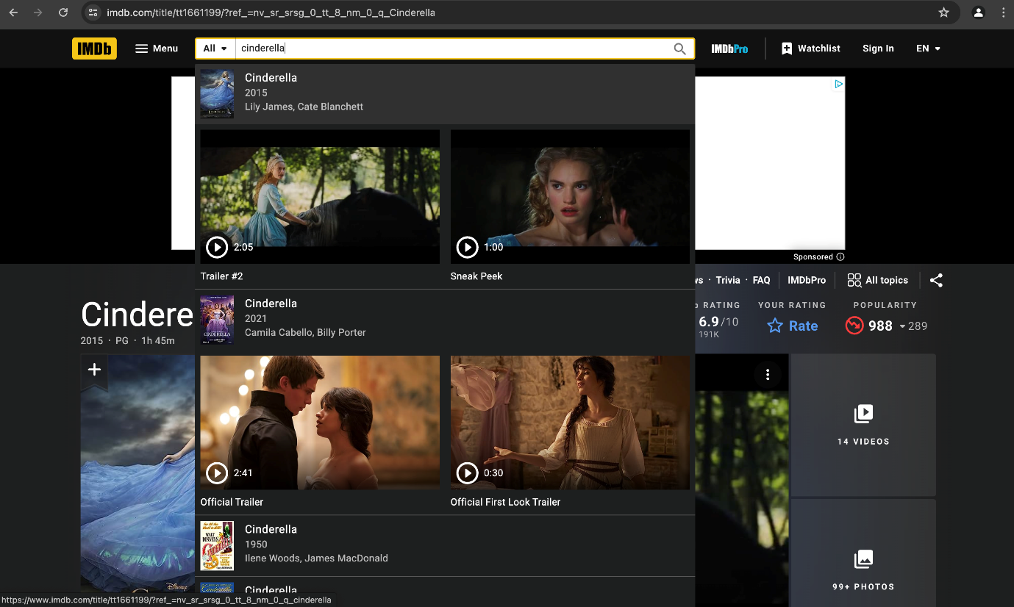

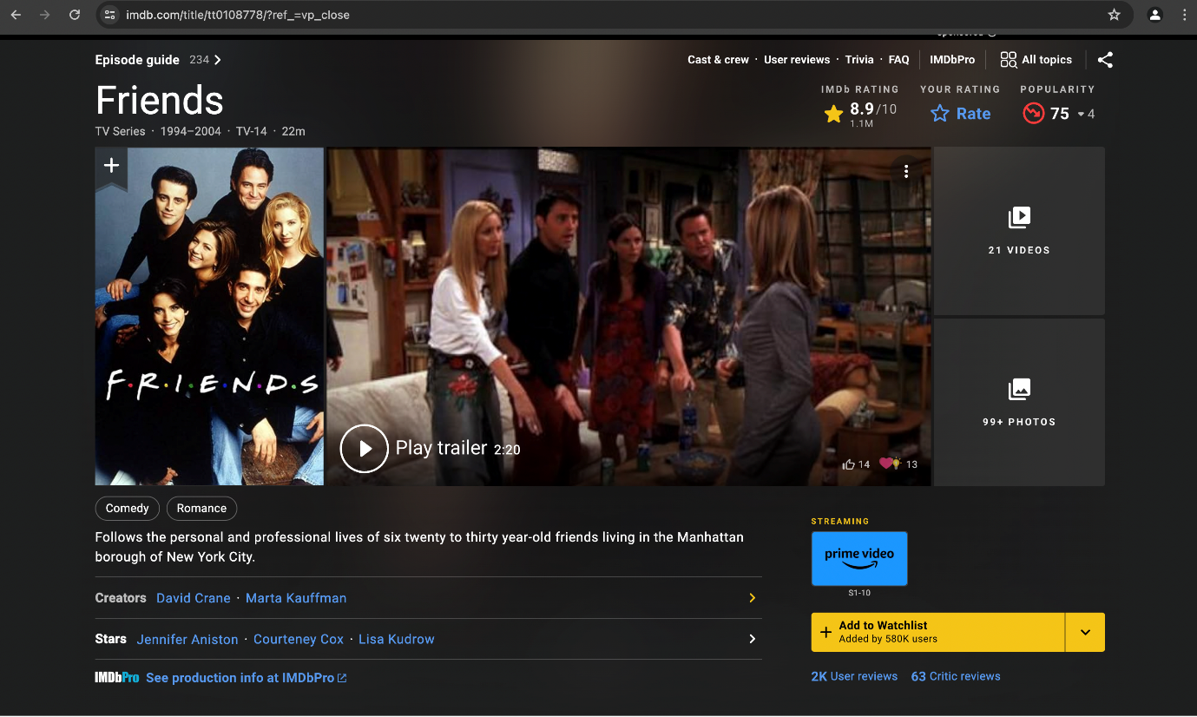

1. **Content Display Testing**

Having analyzed different sections of the website, such as movie listings, TV show pages, and actor profiles, including title, release year, genre, rating, and synopsis displayed correctly and successfully. I didn’t encounter any issues or bugs.

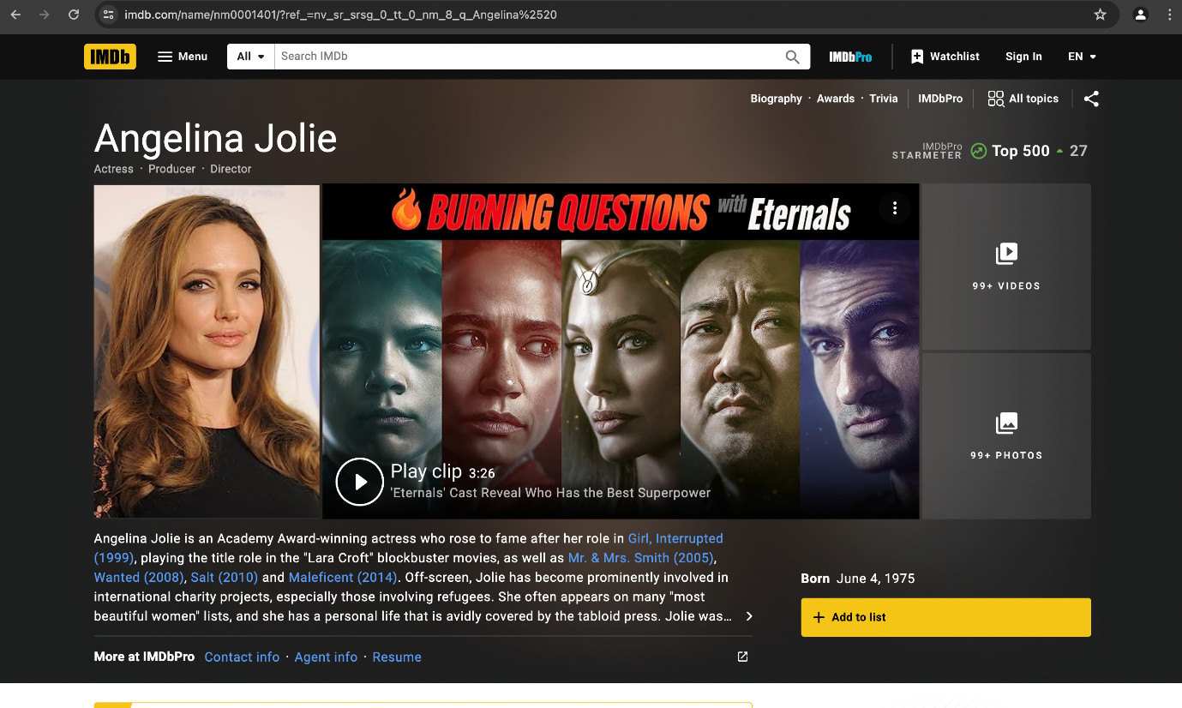

1. **User Interaction Testing**

Clicking on links or buttons leads successfully to the expected destinations, such as movie details pages and actor profiles. All links and buttons are active. Moreover, I can easily rate movies, add them to watch lists and write reviews.

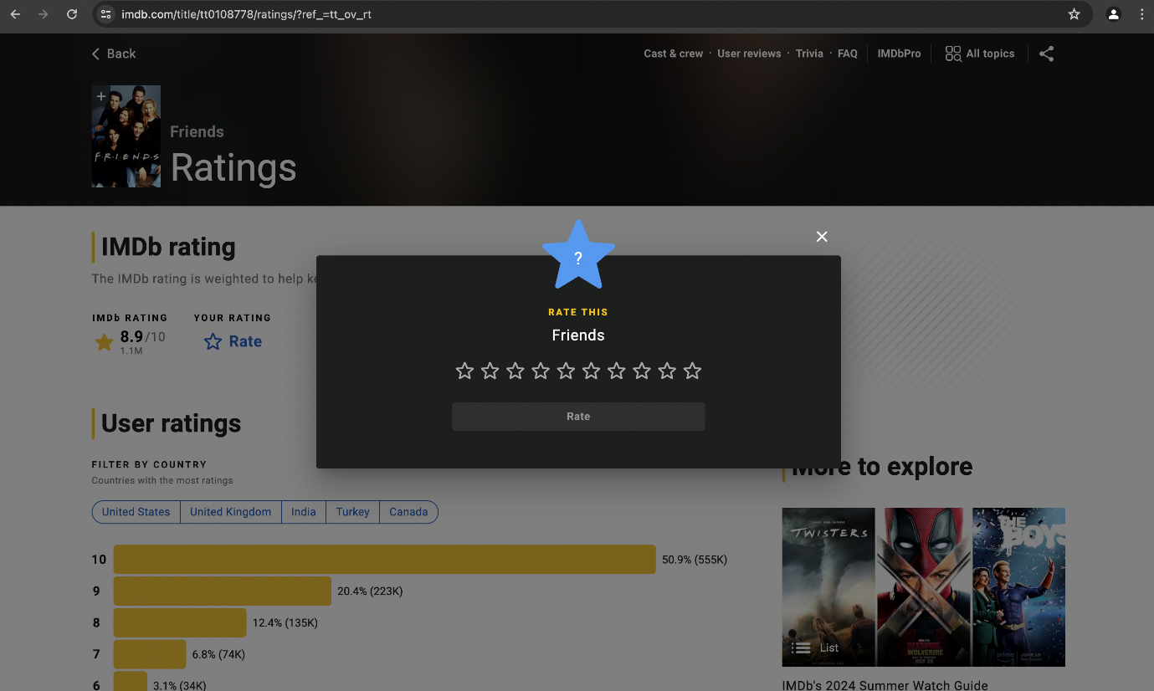

1. **Navigation Testing**

Navigation menu appears in page header on this website, allowing visitors to access the most useful pages quickly. I did not come across with bugs while testing the navigation menu and links to different sections of the website, including home, movies, TV shows, celebrities and more. Users can easily and smoothly backtrack or navigate to parent pages.

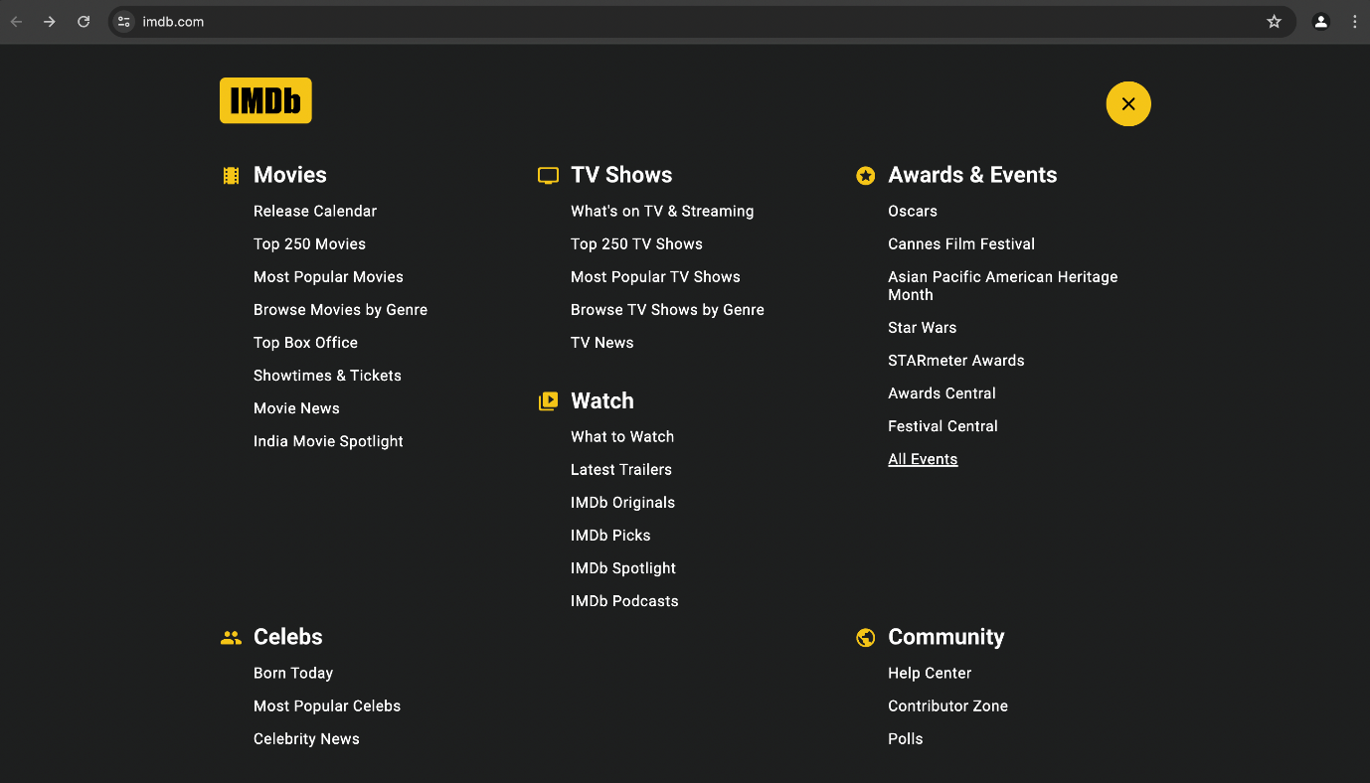

1. **Responsiveness Testing**

The website's responsiveness was successfully tested on various different devices such as desktops, tablets, and mobile phones. Layout adjusts appropriately to different screen sizes and resolutions. The touch interaction on mobile devices was both smooth and user-friendly.



1. **Performance Testing**

By checking the performance of movie trailers and image galleries of the website no defect was found, and pages loaded quickly and smoothly, with minimal latency. Any lag or buffering issues was not detected.

